**Blinkit Sales Performance & Business Insights Report**



📘 **Blinkit Sales Performance Dashboard**  
Real-Time Business Insights Using Power BI  
Power BI Dashboard Link: *Blinkit_Sales.pbix*

🎯 **Project Overview:**  
This project provides a detailed analysis of Blinkit’s sales and operational performance using Power BI as the primary business intelligence tool. The goal is to uncover actionable insights related to sales distribution, item categories, outlet performance, and customer ratings. This dashboard serves as a decision-making tool to enhance sales strategies, optimize outlet management, and improve customer satisfaction across different locations.

🔍 **Scope of Analysis:**  
📊 **Sales Overview:** Total sales performance, average sales per transaction, and total items sold across outlets.  
📈 **Outlet Performance:** Sales and ratings comparison across outlet sizes, tiers, and locations.  
🛒 **Item Category Contribution:** Revenue contribution by item type (e.g., fruits, snacks, dairy, frozen foods).  
📍 **Location Insights:** Performance distribution across Tier 1, Tier 2, and Tier 3 outlets.  
⭐ **Customer Experience:** Analysis of average ratings by outlets and product categories.

🧰 **Tool Used:**

* Power BI Desktop – For interactive dashboard creation and data visualization
* Data Source: Blinkit Sales & Outlet Dataset (Excel/CSV format)

👤 **Prepared By:**  
Shrushti Sah

🔎Problem Statement & Introduction

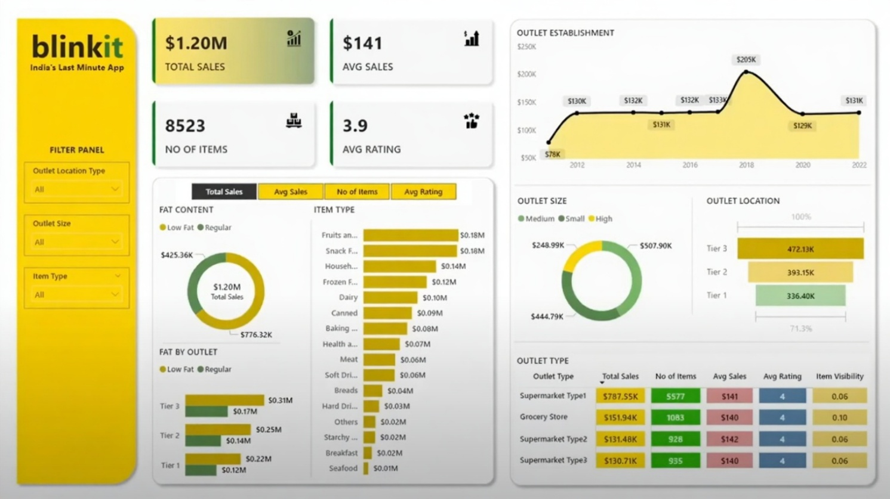

**📌 Problem Statement:  
Blinkit, as a quick-commerce platform, operates through a variety of outlets differing in size, location, and product categories. Despite generating significant sales of $1.20M, the company faces challenges in identifying which outlet types, item categories, and locations drive maximum profitability and customer satisfaction. Without clear visibility, it becomes difficult to:**

* **Allocate resources effectively across outlets.**
* **Improve underperforming categories (e.g., breakfast, seafood).**
* **Enhance customer ratings, which currently stand at a moderate 3.9.**
* **Identify trends in outlet establishments to forecast future sales growth.**

**The dashboard aims to solve these problems by providing a centralized view of all critical sales and operational KPIs.**

**🔍 Introduction & Analysis:  
This dashboard offers a real-time analysis of Blinkit’s performance using multiple lenses: financial, operational, and customer-centric.**

* **Financial Lens: Provides insights into total sales, average sales, and revenue distribution across item categories and outlet types.**
* **Operational Lens: Examines the contribution of outlets based on size (small, medium, high), tier (1, 2, 3), and type (supermarket, grocery).**
* **Customer Lens: Tracks customer experience through average ratings, helping identify areas where service or product quality can be improved.**

**The analysis reveals key patterns:**

1. **Tier 3 outlets are outperforming Tier 1 in revenue generation, which suggests higher demand in non-metro areas.**
2. **High-capacity outlets are driving the majority of sales, emphasizing the importance of large-format retail.**
3. **Customer preference is tilted towards regular fat-content items compared to low-fat options.**
4. **Supermarket Type 1 significantly dominates sales, making it the most critical channel for Blinkit.**

**🧩 Business Impact:  
By addressing these problem areas, Blinkit can:**

* **Optimize supply chain and inventory for top-performing categories.**
* **Strategically expand outlets in high-demand locations (Tier 3 & Tier 2).**
* **Improve customer satisfaction by focusing on service quality in underperforming outlet types.**
* **Support data-driven decision-making to maximize profitability.**

**📊Dashboard Analysis & Insights**

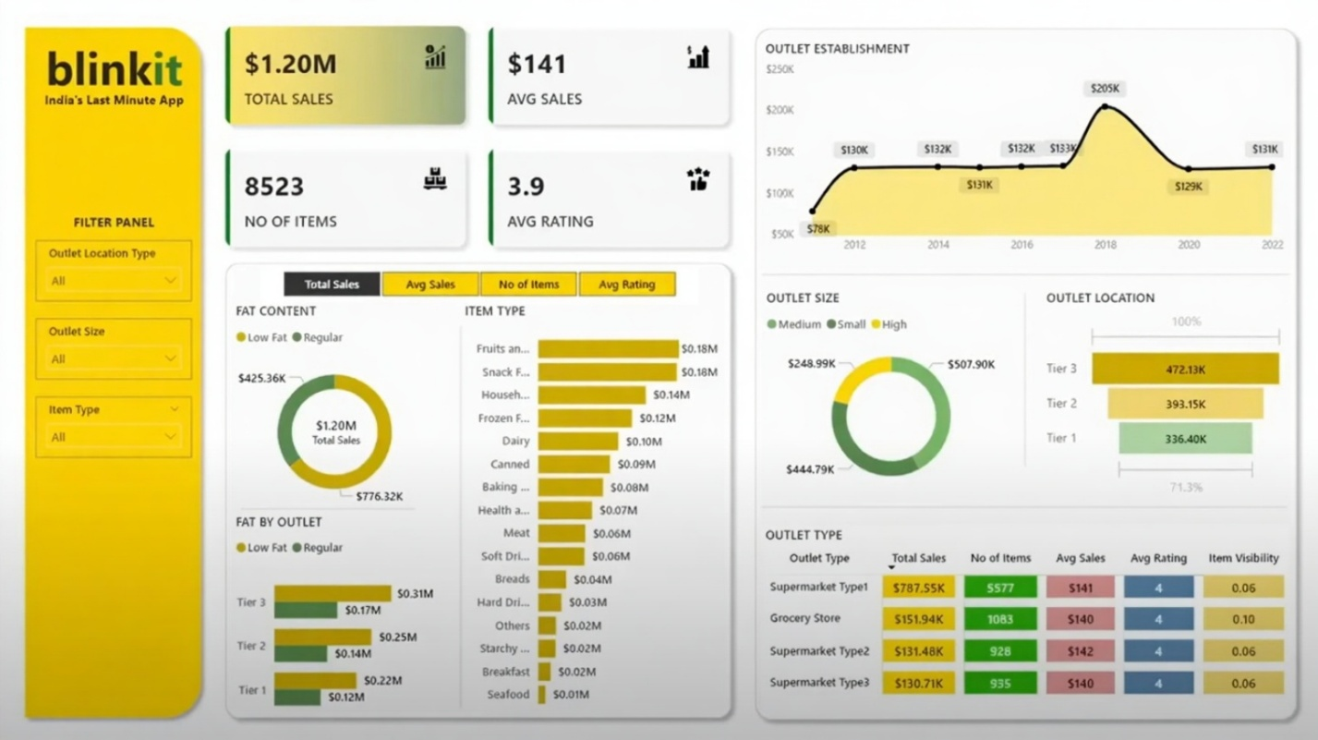

🔍 **Dashboard Objective:**  
The primary objective of this dashboard is to provide Blinkit’s management team with a clear and data-driven understanding of sales performance across different outlets, item categories, and customer segments. By consolidating sales, outlet data, and customer ratings, the dashboard enables stakeholders to identify growth opportunities, optimize underperforming areas, and make informed strategic decisions.

📌 **Key Questions Answered:**  
• What is the overall sales performance, and how do average sales contribute to revenue growth?  
• Which outlet sizes (small, medium, high) and tiers (1, 2, 3) generate the most revenue?  
• How has outlet establishment performance evolved over the years?  
• What are the top and bottom-performing item categories?  
• Which outlet type provides the highest customer rating and sales?  
• How does customer preference differ between regular and low-fat items?

|  |
| --- |
| 📈 **Key Metrics & KPIs:** |
| | **Metric** | **Value** | **Description** | | --- | --- | --- | | **Total Sales** | $1.20M | Overall revenue from all outlets | | **Average Sales** | $141 | Average revenue per sale | | **No. of Items Sold** | 8,523 | Total items sold | | **Average Customer Rating** | 3.9 | Overall customer satisfaction score | | **Highest Revenue Tier** | Tier 3 – $472K | Strongest regional performance | | **Top Outlet Type** | Supermarket Type 1 – $737.85K | Key driver of sales growth | | **Peak Establishment Year** | 2018 – $205K | Year of highest sales performance | |

📊 **Visual Insights:**  
• **Item Category Analysis:** Fruits ($0.18M), snacks ($0.14M), and frozen foods ($0.12M) dominate, while categories like breakfast and seafood generate negligible sales.  
• **Outlet Establishment Trend:** Sales peaked in 2018 at $205K, but recent years show fluctuating growth, requiring further investigation.  
• **Fat Content Preferences:** Regular products ($776.32K) outperform low-fat ($425.26K), suggesting health-oriented products need better promotion.  
• **Outlet Size Impact:** High outlets ($507.90K) lead in revenue, followed by small ($444.79K) and medium ($248.99K).  
• **Geographical Insights:** Tier 3 outlets outperform Tier 1, proving that non-metro markets are more profitable for Blinkit.  
• **Customer Experience:** Ratings remain at 3.9, indicating moderate satisfaction but highlighting potential for service improvement.

**✅ Conclusion & Recommendations**

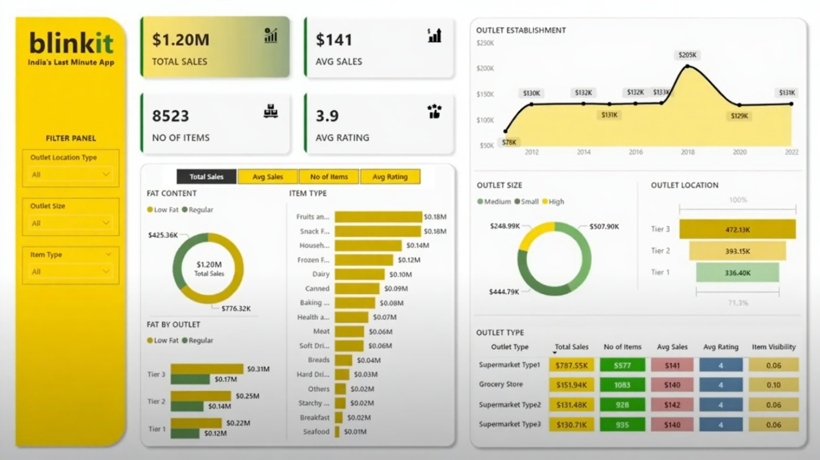

✅ **Summary of Key Findings:**  
The Blinkit Sales Dashboard reveals critical insights into the company’s operational and financial performance. Key findings include:

* **Total Sales** stand at **$1.20M**, with **Tier 3 outlets** and **Supermarket Type 1** contributing the largest share.
* **High outlet sizes** generate the maximum revenue ($507.90K), emphasizing the importance of large-format retail.
* **Customer preference** leans strongly towards **regular fat content products**, with sales nearly double that of low-fat items.
* **Item categories** such as **fruits, snacks, and frozen foods** dominate sales, while categories like **seafood and breakfast items** underperform.
* **Average customer rating (3.9)** highlights moderate satisfaction, suggesting a need for service improvements.
* **Outlet establishment trend** peaked in 2018, followed by inconsistent growth patterns.

🚀 **Recommendations for Business Growth:**

1. **Focus on Tier 3 Expansion:** Since Tier 3 outlets generate the most revenue, Blinkit should prioritize scaling operations in smaller cities and towns where demand is growing.
2. **Strengthen Underperforming Categories:** Develop marketing campaigns and promotional offers for underperforming segments like seafood, breakfast, and low-fat items to balance category performance.
3. **Enhance Customer Satisfaction:** Introduce loyalty programs, faster delivery options, and quality assurance checks to raise customer ratings above 4.2+.
4. **Optimize Outlet Size Strategy:** Invest more in high-capacity outlets, while gradually scaling medium outlets to capture untapped customer bases.
5. **Leverage Data-Driven Inventory Planning:** Use sales trends to forecast demand for top-performing categories (fruits, snacks, frozen foods), ensuring consistent availability.
6. **Reassess Outlet Establishment Strategy:** Investigate post-2018 fluctuations to understand gaps in sales growth and design strategies for sustained revenue improvement.

📢 **Final Note:**  
The Blinkit Sales Dashboard provides a powerful, data-driven lens to monitor performance, identify growth opportunities, and align strategies with customer preferences. By acting on the insights and recommendations outlined in this report, Blinkit can improve profitability, strengthen its market presence, and deliver enhanced value to customers in both metro and non-metro markets.